## 

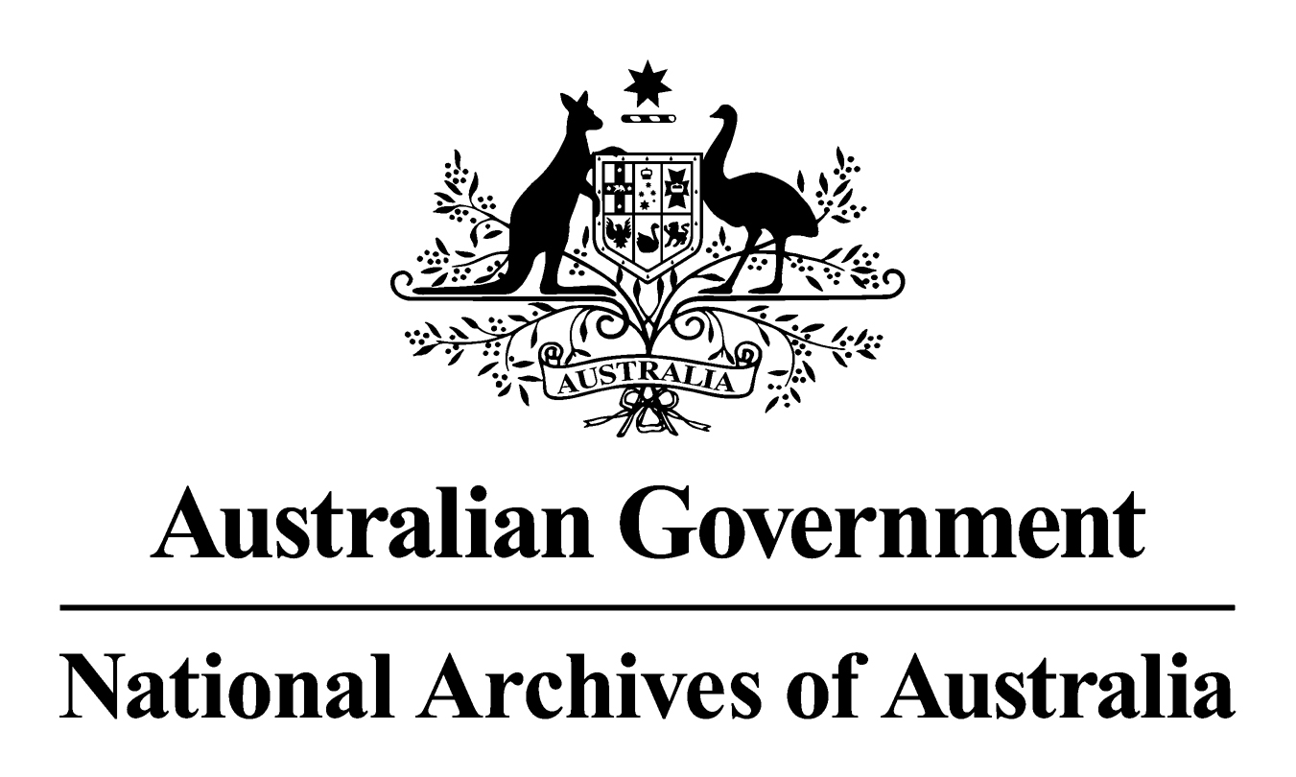

General Records Authority (31)

2012/00540564

***For source (including original) records after they have been copied, converted or migrated***

This is an accurate reproduction of the authorised records authority content, created for accessibility purposes

October 2012

**CONTENTS**

PURPOSE OF THIS AUTHORITY 3

Advice 3

CONTACT INFORMATION 3

AUTHORISATION 4

Class no 5

EXCLUSIONS 5

CONDITIONS 6

a) Application 6

b) Functional equivalence 6

c) Assess agency risks prior to destruction of source records 6

d) Date copy record came into existence 6

e) Digitisation of accumulated RNA or RP source records 6

f) Maintenance of reproductions as records 6

© Commonwealth of Australia 2012

This work is copyright. Apart from any use as permitted under the *Copyright Act 1968,* no part may be reproduced by any process without prior written permission from the National Archives of Australia. Requests and inquiries concerning reproduction and rights should be directed to the Publications Manager, National Archives of Australia, PO Box 7425, Canberra Mail Centre ACT 2610, Australia.

## PURPOSE OF THIS AUTHORITY

Subject to exclusions and conditions, this Authority permits the destruction of source records, including original records that have been successfully reproduced. Reproduction involves the copying, conversion from one format to another or migration from one system to another. This is on the proviso, that the source records are no longer needed for agency or National Archives of Australia purposes.

This Authority commences on 1 November 2012. It supersedes the earlier version of *General Records Authority 31 - for source (including original) records after they have been copied, converted or migrated* (September 2011) which cannot be used after 31 October 2012.

## Advice

Further information about using this Authority can be found in the *Guidelines for using the General Records Authority (31) for source records (including original) after they have been copied, converted or migrated*. These guidelines were written to help agencies understand and successfully implement this Authority.

## CONTACT INFORMATION

For assistance with this authority or for advice on other records management matters, please contact National Archives’ Agency Service Centre.

Queen Victoria Terrace Tel: (02) 6212 3610

Parkes ACT 2600 Fax: (02) 6212 3989

PO Box 7425 Email: [recordkeeping@naa.gov.au](mailto:recordkeeping@naa.gov.au)

Canberra Mail Centre ACT 2610 Website: [www.naa.gov.au](http://www.naa.gov.au)

# AUTHORISATION

|  |  |  |
| --- | --- | --- |
|  |  |  |
| **GENERAL RECORDS AUTHORITY (31)** | For source (including original) records after they have been copied, converted or migrated |  |
|  |  |  |

|  |  |  |
| --- | --- | --- |
|  |  |  |
| **Purpose:** | Authorises arrangements for the disposal of records in accordance with Section 24(2)(b) of the *Archives Act 1983.* |  |
|  |  |  |
| **Application:** | This Authority permits the early destruction after copying, conversion or migration of source records in certain categories, subject to exclusions and conditions. |  |
|  |  |  |

|  |  |  |
| --- | --- | --- |
|  | This authority gives permission for the destruction of the records described. This authority will apply only with the consent of the agency currently responsible for the business documented in the records described. |  |
|  | **Authorised by Date of issue:** |  |
|  | David Fricker 10 October 2012  Director-General  National Archives of Australia |  |
|  |  |  |

| Class no | **Description of records** | **Disposal action** |
| --- | --- | --- |
| 61228 | Source records in the following categories:   * records created on or after 1 January 1995, including those not covered by a current Records Authority, except: * records with intrinsic value that are identified as Retain as National Archives (RNA) or Retain Permanently (RP); or * audio visual records that are not identified as temporary records under a current Records Authority issued by the National Archives of Australia. * records of any age identified as temporary records under a current Records Authority issued by the National Archives of Australia; * records of any age that present a high risk of unplanned loss, alteration, loss of authenticity, integrity, or useability due to technological obsolescence; * records of any age that have never been the format of the agency record used or relied on in the normal course of business. | May be destroyed before their prescribed retention periods (if any) expire, without seeking further authorisation provided that the reproductions are functionally equivalent to the source records.  The attached **Exclusions** and **Conditions** must be observed. |

## EXCLUSIONS

This Authority does not cover the destruction of records that have been reproduced where:

1. the agency considers the record to have intrinsic value in its original format or a specific format and it is identified as:
2. Retain as National Archives (RNA); or
3. Retain Permanently (RP); or
4. meeting the criteria for RNA listed in ‘*Why Records are Kept: Directions in Appraisal’;*
5. the record is an audio visual record that has not been identified as a temporary record under a current Records Authority issued by the National Archives of Australia;
6. there is a legal requirement to retain the record in its original format or a specific format;
7. there is a government policy or directive not to destroy the record;
8. the agency knows it is reasonably likely that the record may be required as evidence in:
   1. a current judicial proceeding; or
   2. a future judicial proceeding that will be commenced or will likely be commenced;
9. the record is subject to a current application for access under the *Freedom of Information Act 1982, Archives Act* 1983 or other legislation;
10. the National Archives of Australia has issued a notice that specifically prohibits destruction of the record;
11. the National Archives of Australia has issued a notice that specifically requires retention of the record in its original format or a specific format;
12. the record is on loan to agencies from the care of the National Archives of Australia.

## CONDITIONS

### a) Application

This Authority may only be applied by an agency with current business responsibility for the records concerned, or their authorised agents.

### b) Functional equivalence

Agencies must ensure that all reproductions are at least functionally equivalent to the source records for business and legal purposes and are managed as records.

### c) Assess agency risks prior to destruction of source records

### Agencies must conduct a risk assessment of the likelihood that the records may be required as evidence in:

### a current judicial proceeding or future judicial proceeding that will be commenced or will likely be commenced; or

* are the subject of a current application for access under the *Freedom of Information Act 1982*, *Archives Act 1983* or other legislation.

Where the agency determines that the source records are reasonably likely to be required, the source records must not be destroyed until after the judicial proceeding or application for access has been finalised.

The agency should regularly review the status of source records retained as a result of risk assessments under this condition.

### d) Date copy record came into existence

Where this authority permits the destruction of original records after digitisation or other copying, for the purposes of the Archives Act, the date a copy record or a subsequent copy record came into existence is taken to be the date that the original record came into existence.

### e) Digitising accumulated RNA or RP source records

Digitisation of accumulated physical records identified as RNA or RP, or which are potentially RNA must follow format standards and verification processes issued by the National Archives of Australia.

This is to ensure that your digital images can be preserved by the National Archives of Australia for future government and public access purposes. Please refer to National Archives of Australia guidance on *"Digitising accumulated physical records" and “Scanning specifications”.*

### f) Maintenance of reproductions as records

Agencies must ensure that the reproductions are maintained in place of the source records for as long as required by any current Records Authority applying to the source records. Further copying, conversion or migration is permissible to achieve this. However, where there is no current Records Authority, agencies must obtain authorisation from the Archives before the latest reproductions are destroyed.