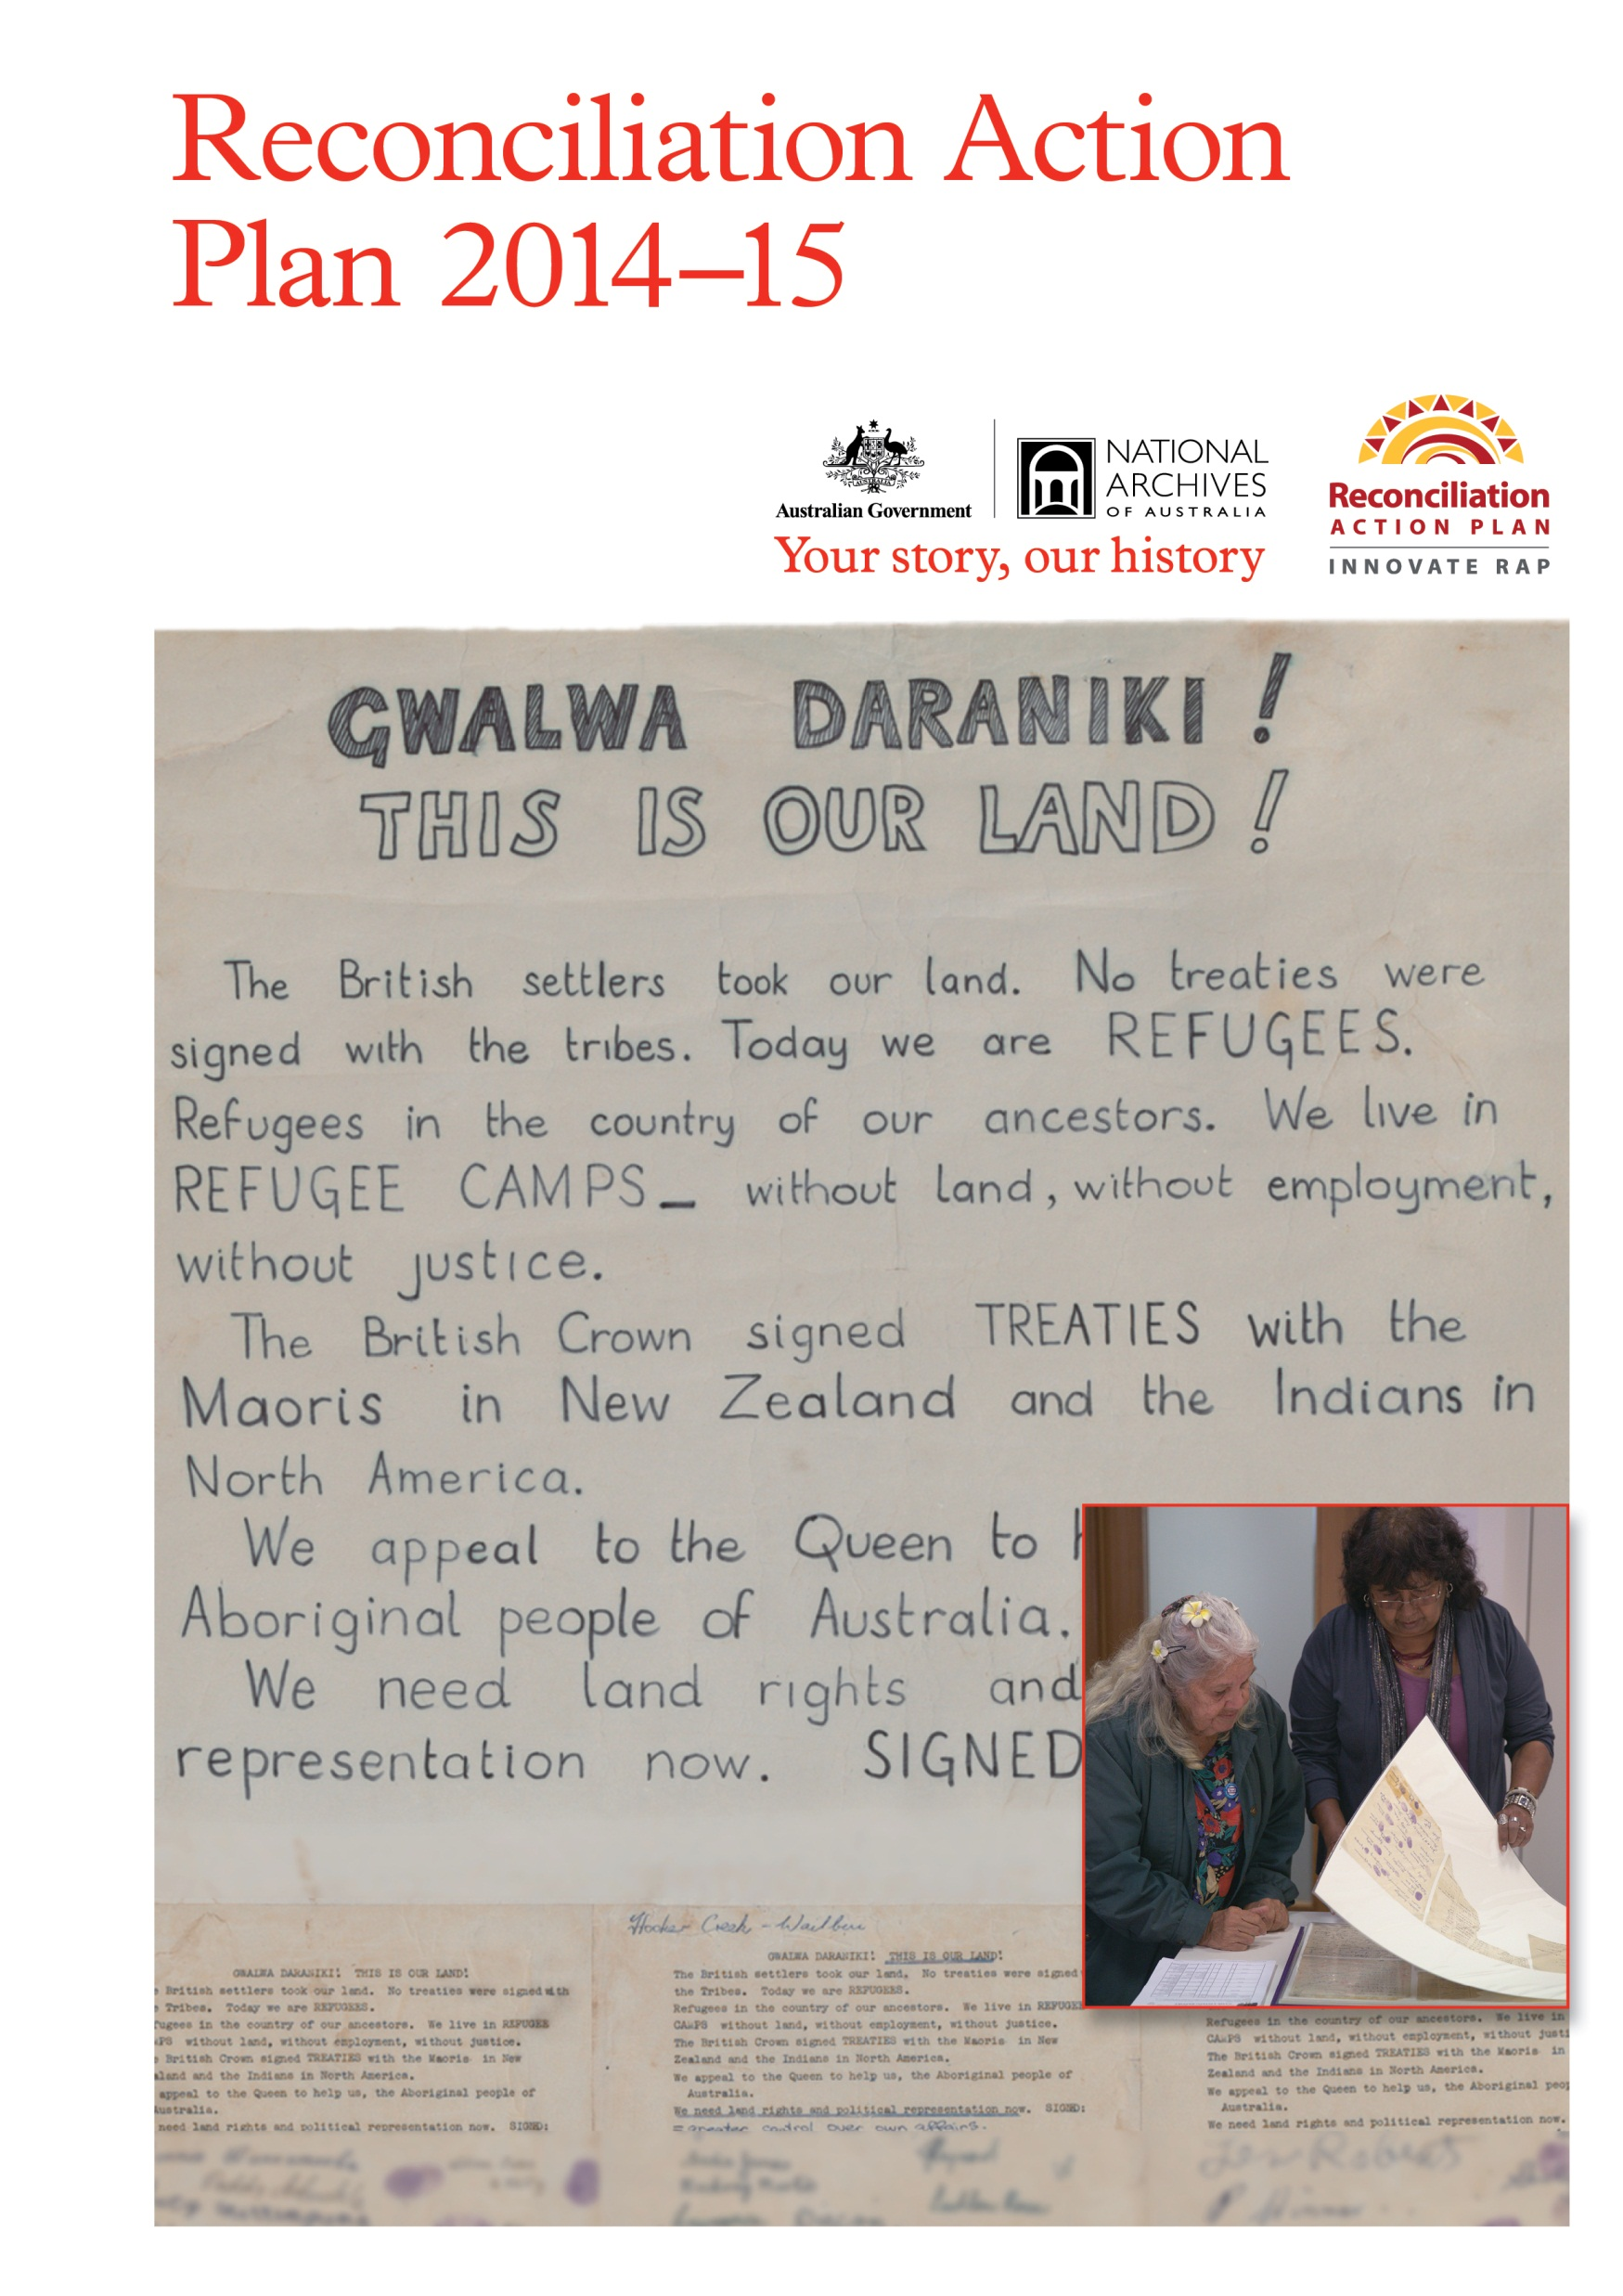

# A message from the Director-General

It gives me great pleasure to present the National Archives of Australia’s Reconciliation Action Plan (RAP) 2014–15.

Through our Aboriginal advisory groups, we have formed solid working relationships in most states and territories. This RAP represents an exciting opportunity to build on these relationships and to find new ways of working together to make records of cultural, historical and personal significance available in culturally sensitive and appropriate ways.

From papers relating to the petition to King George V prepared by William Cooper and the Australian Aborigines’ League in the 1930s to the 1967 Referendum and 1972 Larrakia petition, the National Archives holds many important records that document the political, social and personal histories of Aboriginal and Torres Strait Islander Australians. These records illustrate the unique place that Aboriginal and Torres Strait Islander peoples hold in the history of the nation.

Our RAP aims to broaden and strengthen the National Archives’ capacity to engage with Aboriginal and Torres Strait Islander communities and with all Australians.

It reflects our commitment to raising awareness of the place of Aboriginal and Torres Strait Islander peoples in the nation’s history, making information available in a respectful and appropriate manner, and ensuring appropriate access to records of cultural and historical significance.

The RAP acts as a checklist of initiatives to engage Aboriginal and Torres Strait Islander peoples with the records that document their individual and collective histories.

It also outlines steps to encourage Aboriginal and Torres Strait Islander employment in the National Archives and within the archives and information management profession.

I encourage all members of staff to consider how they might contribute to the overall success of the RAP and to be involved in the National Archives’ commitment to reconciliation.

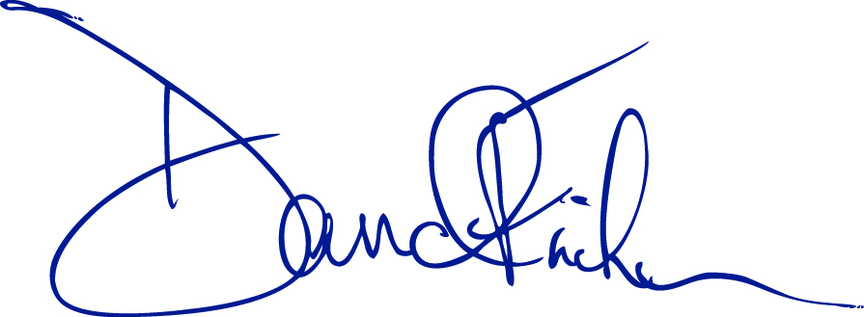

**David Fricker**Director-General  
National Archives of Australia

1 July 2014

# Our vision for reconciliation

We acknowledge the traditional custodians of the lands on which the National Archives’ offices are located and honour their continued connections to those lands.

Our vision for reconciliation is one where an improved general awareness of the culture and history of Australia’s First Peoples will contribute towards greater understanding between Aboriginal and Torres Strait Islander peoples and other Australians. The National Archives recognises the importance of the many stories that make up Australia’s collective history.

Understanding the cultural, historical and social context in which we work is important to fulfilling our two main roles:

* to preserve Australia’s most valuable government records and encourage their use by the public
* to promote good information management by Australian Government agencies.

Our Reconciliation Action Plan (RAP) – through its promotion of mutually beneficial partnerships and projects with Aboriginal and Torres Strait Islander professionals, organisations and communities – will assist us to fulfil these roles.

Our continued engagement with Aboriginal and Torres Strait Islander peoples and communities will assist us in identifying, describing and promoting records of particular relevance to Aboriginal and Torres Strait Islander peoples, developing appropriate services, and encouraging the use of records.

Our involvement with relevant professional organisations, such as the Council of Australasian Archives and Records Authorities (CAARA) Public Access Working Group and the Australian Society of Archivists Indigenous Issues Special Interest Group, will promote relationships with Aboriginal and Torres Strait Islander and other colleagues in the records and archives professions, and assist us in providing coordinated and appropriate services for Aboriginal and Torres Strait Islander peoples.

Through our RAP we aim to:

* build better organisational understanding of Aboriginal and Torres Strait Islander cultures and histories
* build, develop and encourage Aboriginal and Torres Strait Islander employment in the National Archives and encourage interest in archives and information management careers
* respond in a respectful way to Aboriginal and Torres Strait Islander community information needs, including access to records of importance to cultural knowledge and identity
* acknowledge Aboriginal and Torres Strait Islander peoples as custodians of the land, and respect and value the diversity of Aboriginal and Torres Strait Islander cultures in Australia
* promote awareness and active involvement in RAP activities.

The National Archives and its staff recognise the unique place that Aboriginal and Torres Strait Islander peoples hold in our history and our future, and acknowledge and respect their ongoing contribution as the First Peoples of Australia.

# Our business

The National Archives of Australia is a Commonwealth budget funded Executive Agency, established under the *Archives Act 1983*.

The Archives Act identifies our key roles and responsibilities. In particular, the objects of the Act are:

1. to provide for the National Archives of Australia, whose functions include:
2. identifying the archival resources of the Commonwealth; and
3. preserving and making available the archival resources of the Commonwealth; and
4. overseeing Commonwealth recordkeeping, by determining standards and providing advice to Commonwealth institutions; and
5. to impose recordkeeping obligations in respect of Commonwealth records.

To fulfil these functions the Archives undertakes a range of business activities to:

* help Australian Government agencies create and manage their records
* select the most valuable records for retention as part of the ‘archival resources of the Commonwealth’
* make arrangements for the intellectual control of the national archival collection
* house the national archival collection in its own repositories
* preserve the national archival collection
* make records in the national archival collection that are in the open access period accessible to users.

As at 30 March 2014 the National Archives had a full-time equivalent staff of 387, including four staff identifying as Aboriginal or Torres Strait Islander people, working in the national office in Canberra and offices in each state and territory capital.

In 2014–15 the National Archives will focus its reconciliation activities on:

* building a better organisational understanding of Aboriginal and Torres Strait Islander cultures and histories
* encouraging employment of Aboriginal and Torres Strait Islander Australians in the National Archives and the archives and information management professions
* making relevant records and associated services accessible to Aboriginal and Torres Strait Islander Australians in a culturally appropriate manner.

This work will be undertaken in consultation with representatives of Aboriginal and Torres Strait Islander people and with agencies that provide services to them, for example the National Archives’ Aboriginal advisory groups, state archival organisations, Australian Institute of Aboriginal and Torres Strait Islander Studies and Link-Up organisations.

# Our Reconciliation Action Plan

The National Archives’ RAP 2014–15, championed by Director-General David Fricker, draws on the goodwill engendered in its development. The plan also draws on the experience and knowledge of several other organisations, shared at meetings such as the Commonwealth Departments Reconciliation Action Plan forum and the Reconciliation Action Plan Showcase at Parliament House in February 2013.

The RAP outlines the behaviours, activities and relationships through which we demonstrate our respect for Aboriginal and Torres Strait Islander peoples, their cultures and their contribution to Australia’s history. It underscores our commitment to working towards reconciliation and is a guiding document for the National Archives’ reconciliation activities.

The RAP aims to raise awareness of Aboriginal and Torres Strait Islander peoples, histories and cultures within the Archives and to demonstrate our commitment to working towards increased Aboriginal and Torres Strait Islander representation within the archives and information management professions.

It is a living document that will be reviewed and revised regularly in consultation with the National Archives’ Reconciliation Action Plan Working Group, Aboriginal advisory groups, Workplace Relations Committee and Executive Board.

# Our reconciliation journey

## Achievements to date

The National Archives has engaged in a number of activities that have contributed to our reconciliation journey, including:

* hosting the Public Record Office Victoria’s exhibition *Footprints: the journey of Lucy and Percy Pepper* which tells the story of an Aboriginal family in Victoria. A member of the Pepper family gave a talk to staff
* developing for staff via the *Infonet*

o a calendar of Aboriginal and Torres Strait Islander events

o guidelines for Acknowledgement of Country and Welcome to Country

o Aboriginal and Torres Strait Islander employment information, including information from the Australian Public Service Commission

o Aboriginal and Torres Strait Islander Information Guide

* informing staff about the Jawun Aboriginal and Torres Strait Islander Community Secondment Program
* establishing baseline data for Aboriginal and Torres Strait Islander employees
* continued engagement with Aboriginal communities via the National Archives’ Aboriginal advisory groups established under memoranda of understanding covering access to records
* providing copies of the 1972 petition organised by the Larrakia people seeking land rights, a treaty and representation and an accompanying index to the Larrakia Nation
* developing a number of finding aids to assist members of the public to find records relating to Aboriginal people, including *Tracking Family: a guide to Aboriginal records relating to the Northern Territory* and a number of fact sheets
* developing the Bringing Them Home name index with more than 400,000 entries between 1998 and 2004. Staff continue to assist Aboriginal and Torres Strait Islander clients to gain access to the information to enable them to link up with their families and communities
* maintaining ongoing partnerships with Link-Up agencies and the Australian Institute of Aboriginal and Torres Strait Islander Studies to provide services to those affected by former government removal policies.

## Looking forward

Some longer-term goals that will be addressed in future plans include:

* ongoing work to increase awareness of the RAP among National Archives staff
* developing a mentorship program for Aboriginal and Torres Strait Islander staff
* investigating opportunities for cadetships
* developing and implementing cultural awareness training
* reviewing and revising policies, strategies and procedures to ensure that records relating to Aboriginal and Torres Strait Islander peoples are handled and accessed in culturally appropriate ways, in accordance with established protocols and in consultation with relevant communities.

# Relationships

The National Archives holds a range of records that document the individual and collective histories of Aboriginal and Torres Strait Islander peoples. It is important to promote the existence of such records within Aboriginal and Torres Strait Islander communities and to ensure that access to secret/sacred and other sensitive information is provided in a culturally appropriate way. Building relationships with Aboriginal and Torres Strait Islander people is instrumental in raising the profile of the National Archives’ collection within relevant communities and establishes a foundation for engagement and consultation on a more formal level.

**Focus area:** Building and strengthening relationships with Aboriginal and Torres Strait Islander people and communities.

| **Action** | **Responsibility** | **Timeline** | **Target** |
| --- | --- | --- | --- |
| **1** Establish a RAP Working Group made up of representatives from different work areas – including Aboriginal and Torres Strait Islander staff and stakeholders – to support development of the RAP | Assistant Director, Indigenous Unit, Reference and Information Services (responsible for secretariat) | by 30 Sep 2014 | Establish RAP Working Group  Develop and implement a governance framework for the RAP Working Group |
| **2** Celebrate National Reconciliation Week by providing opportunities for Aboriginal and Torres Strait Islander staff and other staff to build relationships. | RAP Working Group, with assistance from Director, People Management and Development; relevant supervisors; directors, Access and Communication; and state directors | 27 May – 3 June 2014, 2015 | Organise at least one internal event each year  Distribute Reconciliation Australia’s calendar of National Reconciliation Week events to staff  Assist staff with transport to internal events where appropriate |
| **3** Maintain the calendar of Aboriginal and Torres Strait Islander events and support staff to participate in cultural and other activities | RAP Working Group with assistance from: Assistant Director, Indigenous Unit, Reference and Information Services; and state directors | 30 June 2015 (and ongoing) | Keep calendar up to date  Support all staff to attend events such as NAIDOC Week activities |
| **4** Encourage and assist staff to establish networks with Aboriginal and Torres Strait Islander communities | RAP Working Group, and Assistant Director, Indigenous Unit, Reference and Information Services | 30 June 2015 (and ongoing) | Develop and maintain a list of key Aboriginal and Torres Strait Islander contacts in each state and territory to assist staff who are organising a Welcome to Country  Arrange information sessions by elders and other community members and/or researchers on relevant topics  Continue engagement with the ACT Indigenous Online Network and establish links with similar organisations in all states and territories |

# Respect

The core role of the National Archives can be expressed as preserving the documented history of Australia and facilitating access to the records that document that history. Respect for Aboriginal and Torres Strait Islander peoples, culture, land and history is vital to the culturally appropriate management of, and access to, records.

**Focus area**: Increased understanding of Aboriginal and Torres Strait Islander peoples, cultures, land and history within the National Archives. A demonstrated commitment to making relevant records and associated services accessible to Aboriginal and Torres Strait Islander people in a culturally appropriate way.

| **Action** | **Responsibility** | **Timeline** | **Target** |
| --- | --- | --- | --- |
| **1** Engage staff in understanding the protocols around Acknowledgement of Country and Welcome to Country ceremonies to ensure there is shared meaning behind the ceremonies | Assistant Director, Indigenous Unit, Reference and Information Services; Director, National Development and Communications; Director, Access Programs; and RAP Working Group | 30 June 2015 (and ongoing) | Continue to raise awareness of the protocols by using them appropriately at staff and public events  Increase staff understanding of the purpose and importance of the protocols by publicising them through the Aboriginal and Torres Strait Islander Information Guide and forum on the *Infonet* |
| **2** Engage staff in cultural learning to increase understanding and appreciation of different cultural backgrounds in order to lay the foundation for other RAP actions to be achieved | Director, People Management and Development; RAP Working Group; Assistant Director, Indigenous Unit, Reference and Information Services; Director, National Development and Communications; Director, Access Programs; and all supervisors | 30 June 2015 (and ongoing) | Develop a cultural awareness plan that recognises the different capacities in which staff engage with Aboriginal and Torres Strait Islander people and collections  Include cultural awareness training options in the plan  Develop a tour covering Aboriginal and Torres Strait Islander records displayed in the National Archives’ permanent exhibition and other original records to be used in engaging National Archives’ staff and staff of other Australian Government agencies in cultural learning associated with reconciliation action plans  Encourage staff to attend relevant events such as those listed in the calendar of Aboriginal and Torres Strait Islander events  Organise staff visits to relevant organisations  Develop basic guidelines on communicating with Aboriginal and Torres Strait Islander people, including appropriate terminology and behaviours, to be available on the *Infonet* |
| **3** Celebrate NAIDOC Week | RAP Working Group; Assistant Director, Indigenous and Reference and Information Services; Director, National Development and Communications; and Director, Access Programs | July 2014 (and ongoing) | Provide opportunities for staff to participate in local NAIDOC Week events  Hold at least one NAIDOC Week event |
| **4** Develop and implement strategies to visually represent and acknowledge Aboriginal and Torres Strait Islander peoples and cultures across National Archives offices | RAP Working Group; Director, Reference and Information Services; Director, National Development and Communications; Director, Access Programs; Director, Facilities; and state directors | 30 June 2015 (and ongoing) | Work towards each National Archives office having on display:  · a plaque or similar acknowledging traditional owners; in 2014–15, as a pilot, install a plaque in the Northern Territory Archives Service  · at least one relevant Aboriginal and Torres Strait Islander image, item or artwork; in 2014–15, survey offices to determine which have material on display and recommend additions or changes  Include wording, including Acknowledgement of Country, in National Archives signature blocks |
| **5** Develop and implement guidelines and communication tools including the Aboriginal and Torres Strait Islander Information Guide | Assistant Director, Indigenous Unit, Reference and Information Services to coordinate, with contributions from Director, National Development and Communications; Director, Access Programs; RAP Working Group; and all supervisors | 30 June 2015 (and ongoing) | Review and revise policies, strategies and procedures to ensure that records relating to Aboriginal and Torres Strait Islander peoples are handled and accessed in culturally appropriate ways, in accordance with established protocols and in consultation with relevant communities  Continue to encourage staff to use the Aboriginal and Torres Strait Islander Information Guide |

# Opportunities

Increasing Aboriginal and Torres Strait Islander employment is an important step in the National Archives’ commitment to providing culturally appropriate services to Aboriginal and Torres Strait Islander people. The National Archives also has a role to play in the promotion of culturally appropriate services and practices within the archives and information management professions. Encouraging Aboriginal and Torres Strait Islander people into the archival profession is a key way of doing so and reflects the recommendations of Aboriginal and Torres Strait Islander Library, Information and Resource Network (ATSILIRN) Protocols for Libraries, Archives and Information Services.

**Focus area**: Increasing Aboriginal and Torres Strait Islander employment at the National Archives and within the archives and information management profession.

| **Action** | **Responsibility** | **Timeline** | **Target** |
| --- | --- | --- | --- |
| **1** Investigate opportunities to assist Aboriginal and Torres Strait Islander people to gain employment within the National Archives | Director, People Management and Development | 30 June 2015 (and ongoing) | Plan for involvement in Aboriginal and Torres Strait Islander employment initiatives such as Australian Public Service Commission Indigenous Pathways program (Indigenous Graduates and Trainees)  Review and update data and strategies on the employment of Aboriginal and Torres Strait Islander people |
| **2** Build partnerships and/or projects that are mutually beneficial with Aboriginal and Torres Strait Islander professionals, organisations or communities | Assistant Director, Indigenous Unit, Reference and Information Services; Director, People Management and Development;  RAP Working Group; and other relevant functional areas | 30 June 2015 (and ongoing) | Continue involvement in:  · Australian Public Service Commission Human Resources Indigenous Employment Network  · Public Access Working Group of the Council of Australasian Archives and Records Authorities (CAARA) project on a guide to Aboriginal and Torres Strait Islander records  · Australian Society of Archivists Indigenous Issues Special Interest Group  · Aboriginal and Torres Strait Islander Library and Information Resource Network (ATSILIRN) |
| **3** Investigate strategies to encourage Aboriginal and Torres Strait Islander people into the archives and information management profession | Access and Communication directors; RAP Working Group; and Director, People Management and Development | 30 June 2015 (and ongoing) | Review all ongoing and non-ongoing positions as Aboriginal and Torres Strait Islander identified where appropriate  Investigate opportunities for work placements  Encourage visits from groups such as Indigenous Leadership Centre students and school groups with Aboriginal and Torres Strait Islander students |
| **4** Investigate the mutually beneficial opportunities that supplier diversity will provide to the National Archives | Director, Facilities | 30 June 2015 | Investigate becoming a member of the Australian Indigenous Minority Supplier Council |

# Tracking progress and reporting

|  |  |  |  |
| --- | --- | --- | --- |
| **Action** | **Responsibility** | **Timeline** | **Target** |
| **1** Report achievements, challenges and learnings to Reconciliation Australia for inclusion in the Annual Impact Measurement Report | RAP Working Group Chair, through secretariat | 30 June 2015 (and ongoing) | Report progress each year in the RAP Impact Measurement Questionnaire  Report progress to the National Archives’:  · Executive Board  · Aboriginal advisory groups  · Workplace Relations Committee  · staff through the *Infonet*  · stakeholders through the annual report  Report specific issues to:  · the relevant Assistant Director-General  · National Archives Aboriginal advisory groups and other appropriate organisations |
| **2** Attend Commonwealth RAP forum | Assistant Director and Project Officer Indigenous Issues, Indigenous Unit, Reference and Information Services | 30 June 2015 (and ongoing) | Attend all relevant forums |

# Contacts

Hilary Rowell  
Assistant Director   
Indigenous and Reference Projects  
Reference and Information Services  
Access and Communication  
(02) 6212 3960  
[hilary.rowell@naa.gov.au](mailto:hilary.rowell@naa.gov.au)

Rebecca Bateman  
Project Officer Indigenous Issues  
Reference and Information Services  
Access and Communication   
(02) 6212 3607  
[rebecca.bateman@naa.gov.au](mailto:rebecca.bateman@naa.gov.au)

**Cover images**Larrakia petition, 1972 (detail). NAA: A2354, 1973/86; Kathy Mills and Margaret Furber, members of the Northern Territory Aboriginal Advisory Group, looking at the Larrakia petition.